Name of Group:
____________________________

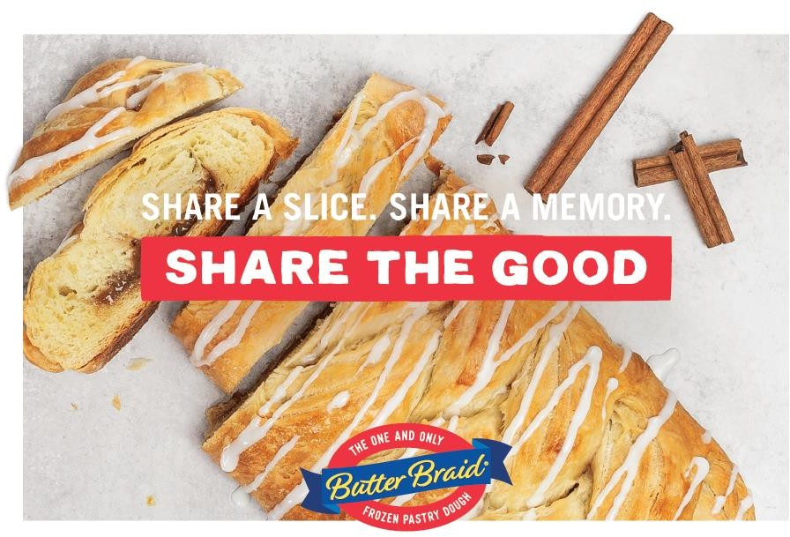
Fundraiser
We’ve partnered with Sweet Manna Fundraising to raise money for our group! We’re selling Butter Braid® Pastries – delicious frozen pastries that are baked at home.

The pastries will be delivered frozen and must stay frozen until ready to bake.
Our Profit Goal is

Each participant should sell at least pastries to ensure we reach our goal.

Return order forms by:
Fundraiser purpose:

Contact name:

Delivery date:

THANKS FOR YOUR SUPPORT!

